
\

ICT Project Proposal (Individual)

HNDIT1052– Individual Project
Crochet Design Collection Website
A PROPOSAL PRESENTED BY
Name :- A.B.C.U. Basnayaka
Index Nu :- RAT/IT/2023/F/0080

Department of Information Technology
Advanced Technological Institute
Ratnapura
2023

Contents
List of Table i
Introduction 2
Background & Motivation 3
Goal, Objectives and Scope of the project 3
Proposed Solution 4
Resource Requirement 4
Project Plan 5
Reference 5

List of Table

- Table 01……………………………………………………………………………………….5

Introduction

Client Name :- A.K.N.M.Gunathilaka
Client Address :- No 130/22
Rassagala Road,
Balangoda
Client Tel :- 071-6067303
Client Facebook Page :- Crochet Design Collection
Summarize the problem
- Less customer experience.
- Many people don’t know about the Facebook marketing. So they are afraid to order the items. It’s a big problem for marketing

- Less credibility. Because anyone can create a Facebook page even using fake data.
- Online marketplaces, particularly Facebook, can lead to less credibility due to factors such as ease of creation, fake profiles, lack of regulation, limited accountability, manipulated user reviews, and higher risk of scams and fraud. Facebook's open environment allows sellers to set up shop without robust vetting processes, making it difficult for buyers to ascertain the legitimacy of sellers. To mitigate these issues, buyers should exercise caution, conduct thorough research, and look for verified sellers or established businesses when making purchases on platforms like Facebook.

- Facebook has less online searching share compared to Google.
- Facebook, a social networking platform, has a smaller online search share compared to Google, which can impact sellers in several ways. Firstly, sellers may struggle to gain visibility for their products due to Facebook's focus on social interactions and algorithms, which may not prioritize product listings. Secondly, Facebook's search capabilities are not as robust as Google's, making it difficult for sellers to optimize their listings for search. Thirdly, sellers often rely on social engagement, which can be challenging without a strong social media strategy. Fourthly, Facebook's target audience may be limited, as users may not be actively looking to make a purchase, leading to lower conversion rates. Fifthly, sellers may need to invest in paid advertising to overcome these limitations. Finally, building trust on Facebook can be challenging due to less emphasis on product searches.

- Some Facebook terms and conditions may affect to the businesses

- Facebook's seller side policies significantly impact businesses, including strict advertising guidelines, Marketplace policies, data privacy and user consent, intellectual property rights, community standards, payment processing, account management, and content ownership. Sellers must adhere to these policies to reach potential customers, avoid penalties, and maintain a strong brand image. Understanding and adhering to these policies can help sellers navigate the platform and mitigate risks.

Background & Motivation

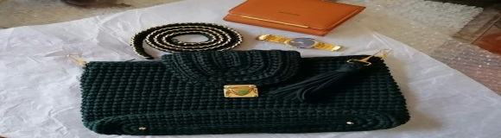
- Our lives are largely dependent on the Internet, which we use for communication, news gathering, networking with friends and colleagues, sharing information, and accessing resources. Both large and small businesses use websites as a platform to sell goods and services, but we have noticed that there is a dearth of free, user-friendly interfaces available for independent business owners to use in order to run their operations online. In my topic Facebook page, online businesses are facing so many problems. Some of them I explain before. For my project, I wanted to offer business owners an online store interface that is simple to use and allows customers to purchase goods and services. The primary goal of the interface is to enable interaction and transactions between a business and its clients.

Goal, Objectives and Scope of the project

Goal
- Popularizing the name of the business among the Sri Lankan peoples and foreigners.
Objective
- The project involves creating a custom website for online Crochet Design Collection.
- The main objects is provide business owners with Shopping cart, an easy-to-use online store interface to sell their product and services
Scope
- The project involves creating a custom website for online crochet design sales, with an admin responsible for managing product details and users. The development in my project include a, front end & customers can get a more details about the items with the goal of being scalable for user growth.

Proposed Solution

- Website Design

  - Select a Template: Pick a mobile-friendly template and customize it with your brand’s logo and colors.
- Product Management
  - Organize Products: Add crochet design with clear images, descriptions, and prices. Use categories to make browsing easy.
- Content Management
  - Information Pages: Add pages about products & Offer options for regular deliveries
- Customer Support
  - Live Chat: Offer live chat support.
  - Help Center: Provide a FAQ section and contact information.
- Maintenance
  - Regularly update and maintain the website

Resource Requirement

Hardware :
- Processor – Intel(R) Core(TM) i5-2500 CPU @ 3.30GHz 3.30 GHz
- System type - 64-bit operating system, x64-based processor
- RAM - 2.00 GB
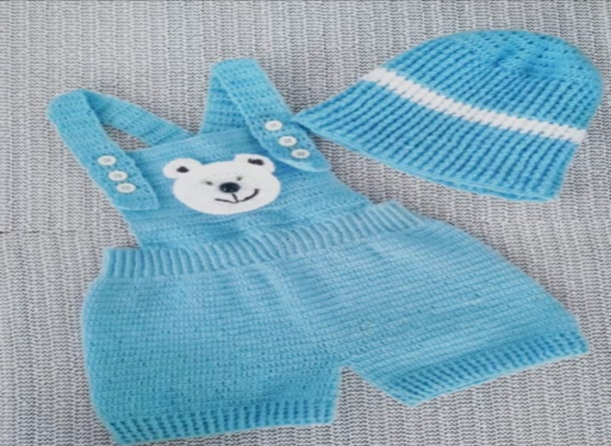
Software :
- Operating System - Windows 10 Pro or above
- Front End – HTML, CSS, JavaScript



Project Plan

Time Line
 | Name | Start | End | Duration | August | September | October | November
 | Project Proposal | 31.08.2024 | 04.09.2024 | 01 Week
 | Planning | 05.09.2024 | 11.09.2024 | 01 Week
 | Design | 11.09.2024 | 23.09.2024 | 02Weeks
 | Development | 24.09.2024 | 11.10.2024 | 02Weeks
 | Testing | 12.10.2024 | 24.10.2024 | 02Weeks
 | Error Handling | 25.10.2024 | 31.10.2024 | 01 Week
 | Launch | 01.11.2024 | 07.11.2024 | 01 Week
(Table 1)

Reference

https://www.facebook.com/share/p/QBV2C6weqGCMvqja/?mibextid=qi2Omg


